AI BlogNest API – Project Documentation
1. Introduction
Project Title: AI BlogNest API
Team Leader: Sri Varthini R & srivarthininkrcs@gmail.com
Team ID: SWTID-2026-4753

Team Members:
1. Sindhu B & sindhunkr2007@gmail.com
2. Navaneetham S & navaneethamnkr@gmail.com
3. Shanmugapriya A & shanmugankrcs@gmail.com

2. Project Overview
Purpose:
AI BlogNest API is a backend web service designed to create, manage, and organize blog content through RESTful APIs. It provides structured endpoints for user operations, blog post management, authentication, and AI-assisted blog content generation. The system uses Node.js and Express.js for the backend and MongoDB for storing application data.
Features:
- User registration and login

- Secure API authentication

- Create, read, update, and delete blog posts

- Search and retrieve blog content

- AI-assisted blog content generation

- MongoDB database integration

- RESTful API architecture

3. Architecture
Frontend / API Client: Postman / Web client
Backend: Node.js with Express.js
Database: MongoDB with Mongoose
AI Service: Google Gemini API

4. Setup Instructions
Prerequisites:
- Node.js

- MongoDB / MongoDB Atlas

- Git

- Visual Studio Code

- Postman

- Google Gemini API Key

Installation Steps:
git clone <repository-link>
cd AI-BlogNest-API
npm install
npm run dev

Create a .env file and configure the required database and AI API environment variables before starting the server.

5. Folder Structure
AI-BlogNest-API/
|-- src/
| |-- controllers/
| |-- models/
| |-- routes/
| |-- middleware/
| |-- services/
| |-- server.js
|-- .env
|-- package.json
|-- README.md

The project separates routes, controllers, database models, middleware, and AI-related services to keep the backend organized and maintainable.

6. Running the Application
Backend:
npm run dev
Server Access:
http://localhost:5000
The API can be tested using Postman by sending HTTP requests to the available endpoints.

7. API Documentation
Authentication APIs
POST /api/auth/register
POST /api/auth/login
User APIs
GET /api/users/profile
PUT /api/users/profile

Blog APIs
GET /api/blogs
GET /api/blogs/:id
POST /api/blogs
PUT /api/blogs/:id
DELETE /api/blogs/:id

AI Blog APIs
POST /api/ai/generate
POST /api/ai/improve

8. Authentication
AI BlogNest API uses token-based authentication to protect private API operations. After successful login, the authenticated user can access protected routes by providing the required authorization token in the request.

9. User Interface / API Testing
The API can be tested through Postman or another REST API client. The main testing screens include:
- Login / Register API

- Blog Creation API

- Blog List API

- Blog Update API

- Blog Delete API

- AI Content Generation API

10. Testing
Manual API testing is performed during development using Postman. Requests are checked for correct status codes, response messages, validation, authentication, database operations, and AI-generated responses.

Tools Used:
- Postman

- Visual Studio Code

- MongoDB Atlas / MongoDB Compass

- Chrome DevTools

- Node.js and npm
11. Screenshots or Demo

Add screenshots of:

User Registration :
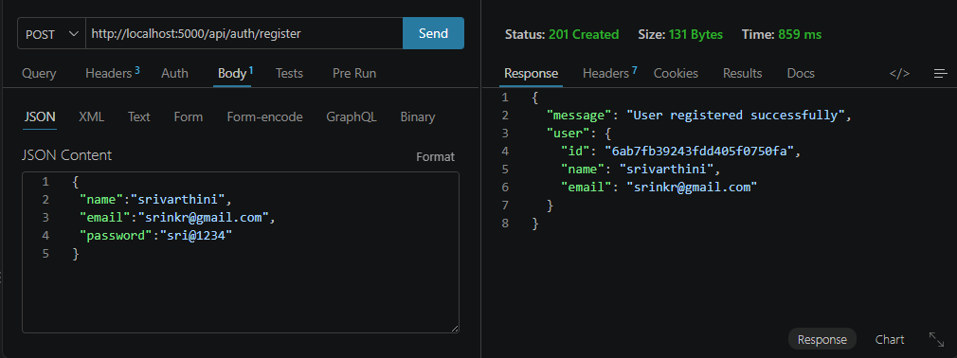

User Login:
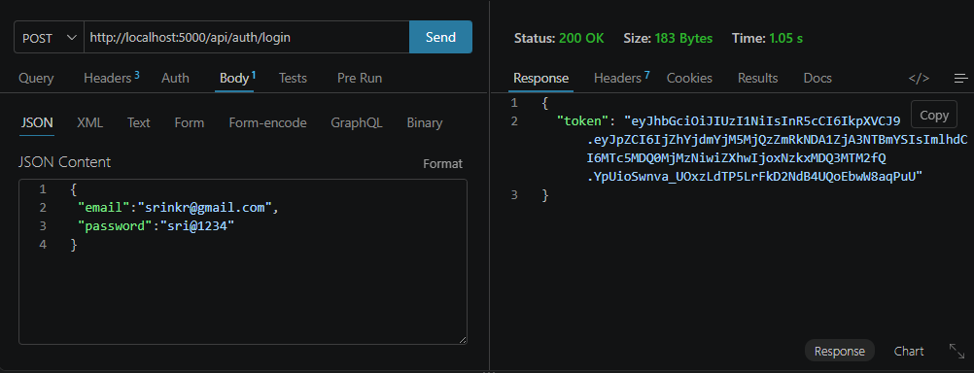

Create Blogs :
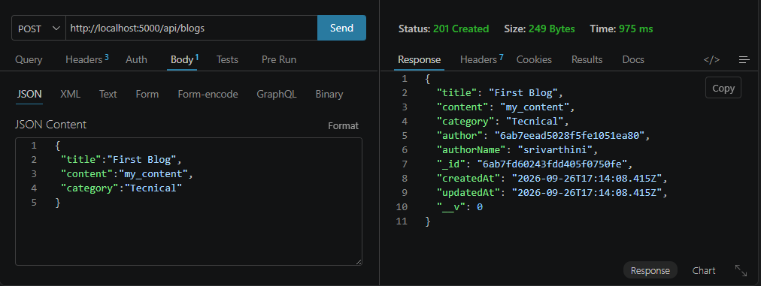

Fetch Blogs :
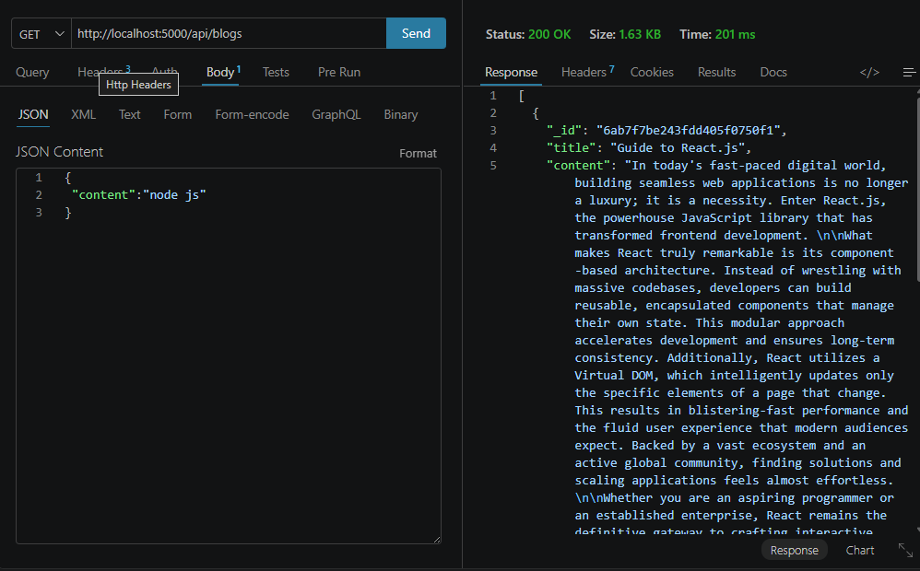

Generate AI blogs :
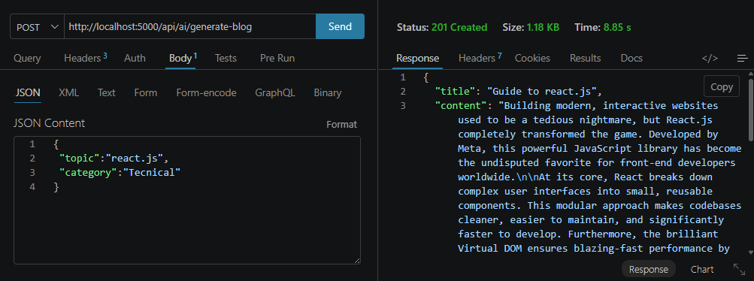

Summarize Blogs :
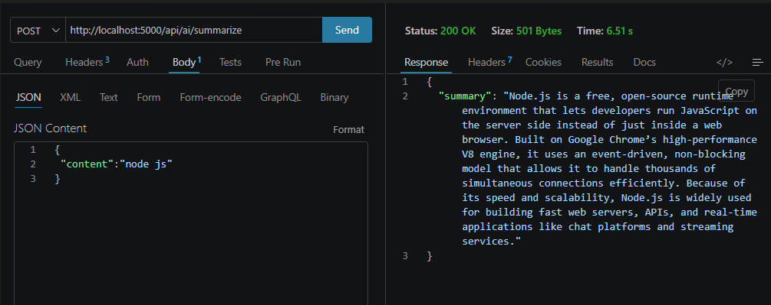

12. Known Issues
- AI-generated content depends on the availability and response of the configured AI service.

- Invalid or incomplete request data may return validation errors.

- Database connectivity is required for blog and user operations.

13. Future Enhancements
- Add image generation for blog posts

- Add blog categories, tags, and advanced search

- Add comments and engagement features

- Add role-based access control

- Add analytics for blog performance

- Improve AI content personalization

- Deploy the API to a cloud platform

Sample Backend Code (Node.js + Express)
Basic Express API structure used for handling blog operations:
const express = require("express");
const app = express();
app.use(express.json());
let blogs = [];
app.get("/api/blogs", (req, res) => {
res.json(blogs);
});
app.post("/api/blogs", (req, res) => {
const blog = req.body;
blogs.push(blog);
res.json({ message: "Blog created successfully", blog });
});
app.put("/api/blogs/:id", (req, res) => {
const id = req.params.id;
blogs[id] = req.body;
res.json({ message: "Blog updated successfully" });
});
app.delete("/api/blogs/:id", (req, res) => {
const id = req.params.id;
blogs.splice(id, 1);
res.json({ message: "Blog deleted successfully" });
});
app.listen(5000, () => {
console.log("AI BlogNest API running on port 5000");
});
The above sample demonstrates the basic REST API flow. In the complete AI BlogNest API project, these operations are connected to MongoDB through Mongoose and can be extended with authentication, validation, and AI services.

